Full Length Research Article
TOWARDS OPTIMIZATION OF TORQUE PEDALS BY MODELING BELT CONVEYORS AND SPEED CONTROLLERS OF A VEHICLE DRIVE TRAIN

¹Fatima Isiaka, ²Chaku Shammah Emmanuel*, ²Ahmed Ibrahim

¹Department of Computer Science, Nasarawa State University, Keffi
²Department of Statistics, Nasarawa State University, Keffi

*Corresponding Author Email Address: chakushammah@nsuk.edu.ng

ABSTRACT
One of the most important components of engine systems on power train is its sole purpose of transmitting engine power to its tracks. This paper demonstrates an engine system by illustrating belt conveyors attached to power train which serves as a booster for motor drives and also speed control for its induction unit. The emphases was mostly on the converters by modeling the frequency converter element which requires an AC voltage and Speed controllers or torque controls. A real time simulation was made and frequent observation of its motor controls was conducted by running simulations on all control motors and comparing the bit error rate of each machine. The result shows synchromesh transmission or accelerated patterns based on friction, the strand velocity, air Gap and torque controls, and this would help build advanced engine drive systems for future power trains on heavy machines.

Keywords: Vehicle, Velocity, Belt Conveyors, Torque controls, SVM.

INTRODUCTION
The main focus of this paper is based on mass simulation and deployment of a vehicle drive train, which includes its strand velocity, friction, air gap and speed controllers with optimization as our main focus. Although more conventional hybrid based machines with light duty vehicles and fuel-efficient gas vehicles can provide valuable fuel savings and environmental benefits, they mostly rely heavily on the gas and thus should be considered as preliminary step towards a more visionary transportation solution. Here, we mostly focused on creating a virtually impressive environment to look at the contributory parts to the vehicle drive train and probably make improvements to its infrastructure and battery technology (see Boldea & Nasar, 1975; Dahmen & Saupe, (2011), Sjogaard, 1975, Yang, 2019).
Just like most transformative new technologically oriented machinery, a vehicle drive train creates variety of potent economic development challenges and opportunities. While electric vehicle market is mostly still relatively at its early stage of development, it is poised to reshape industries and communities worldwide (see May, 1973, Coyle et al, 1979 and Fenn & Marsh, 1935, Biecek, 2019). In this section, we provide a quick overview of potential benefits of vehicle drive train to economic developers that can better assess what the evolution of its marketing or production will mean to rural environment. Most recent demands on cars, trailers and trains are a challenge and an opportunity to capitalize on new vehicle technologies and also in the process reap developmental benefits economically. Vehicle trains creates additional economic development opportunities by improving the quality of transportation that is of benefit, such as reducing energy spending and decreasing its reliance on most foreign and local transportation medium (see Dern et al, 1947; Fenn & Marsh, 1935; Fugl-Meyer et al, 1980; Carvalho et al, 2020). Some of its hurdles to development and possible solutions to transportation means are vividly illustrated in Table 1.
One of the major part of vehicle train is the transmission, which is also known as the gearbox (Figure 1), a system of gears located behind the engine or machine between the clutch box and the propeller shaft. This transmission box provides the mechanical advantage that enables the engine to drive the vehicle. The box contents also allows the operator to control the engine power and speed of the vehicle. Some of the vehicle and construction equipment have automatic and auxiliary transmissions (Christenson, 2000, Mu et al, 2020).
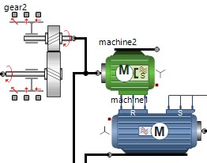
Figure 1: Vehicle train machine configuration with gearbox for engine transmission

The main purpose of the gear or transmission box is to provide the operator a selection of gear ratio between the engine and wheels, with this, the vehicle can operate under a variety or numerous operating conditions and loads. Some of this advantages include supplying different gear ratios to match different engine load conditions, increase torque movement to the rear wheels for quick acceleration, operate with constant speed, quiet and minimum engine power loss, having a reverse gear ratio for backward movement of vehicle and finally provide the operator with an easy means of shifting transmission gears (see Ciosk, Giierzak and Mendrela, 1998, Mendrela, 1996, Ivy et al, 1981 and Komi, 1973).
An analytical automatic transmission was designed to match the load requirements on the vehicle train to the engine or machine power and speed range by speed controlling of its engine (Figure 3). The automatic transmission does not process a shifting power, its shifts depends on the throttle position vehicle speed, and position of the lever selector or drum brake scam. An automatic transmission is used on vehicle train with two to five propellers and equipped with an overdrive (see McCartey, 1983, Ettema & Loraas, 2009, Dyck, et al, 2005 and Nasar & Boldea, 1976). The brief operator control is limited, such that the operator selects a particular gear by moving the transmission pivot or pointer at the tail station. Another point is that the automated transmission is attached or coupled to the engine by the torque pedals, which is a kind of fluid coupling. This is a transmitter with rotation mechanical power and also used as an alternative to the mechanical clutch. It works by slipping at an idle speed and by holding its improved power gauge as the engine speed increases (see Hochtl, Ohm and Senner, 2010, Gander, Golub and Strebel, 1994 and Lee & Chin, 1979, Anwer et al, 2021).

Most belt conveyors (Figure 2) for a vehicle drive train are an endless belt attached together and moving over two ends with pulleys at a fixed position and used for transporting material horizontally or at an inclined up and down position or route. These belt forms the moving and supporting surface on which the conveyed materials rides. Most belt conveyors are selected based on materials to be transported as attractive element (see Faria, 2009, Oberret, 1977 and Fleischer et al, 2021). The idlers form a supportive wedge for carrying and returning stands for the belts, the pulleys supports the movement of the belts and also controls its tensions while the drive and structure impacts power to one or more pulleys that move the loads and maintain the alignments of the idlers and the driving machinery. The belt conveyors are widely used in mineral industries such as underground mine transport, open-cast mine transport and for processing plants deploy of different kinds that adopts the specific job requirements. Its main advantage is the availability of a wider range of materials that can be handled through pause problems in transportation means. The belt conveyors can be used for abstractive, dirty materials, wet or dry and sticky materials. A lump sized transported material is limited by the width of the conveyor belts, which is up to 300mm wide and used mostly in mining industry (Maple, 2001). It can also contain higher capacity materials and any other form of conveyor at a considerably lower cost per tonne kilometer
Additionally, with belt conveyors, longer distances can be covered by vehicle trains more economically than any other transportation system (Thorstensson et al, 1976,; Tihanyi et al, 1982 and Christensen et al, 2000). A single belt conveyor or a series of belt conveyors can perform this function. The belt conveyors can be adopted for cross-country laying. By using many forms of auxiliary equipment such as mobile trippers for spreaders, bulky materials can be distributed and deposited whenever required. Other functions can be performed with the basic conveying like weighing, drying, cooling, spraying and sampling etc. Based on structure, it is one of the lightest forms of conveying machine and comparatively less expensive, its supporting structures can be used for many otherwise impossible structures such as crossing valleys and streets. Most belt conveyors can be adopted for special purposes such as water resistance, fire and corrosion resistant and can also be integrated with other equipment. Its configuration can either be inclined or declined or a combination of both. Based on labor reduction, the operation and maintenance of belt conveyor system is minimal (Vandervoort, 2007). For underground functionality, mine transport using belt conveyor can be used in thin seams as it eliminates the rock works that may otherwise be necessary to gain haulage height. And moreover belt conveyors can provide continuous haulage service from pit bottom to surface edge.
Some of the limitations of belt conveyors include loading and transferring points meet, to be properly designed. A number of protective devices have been incorporated to save the belt from getting damaged by operation problems. They also need higher initial tension of 60 − 300% of useful pull. The use of belt is restricted by the lump size. Part of its limitations include conveying of sticky materials, a problem associated with cleaning and discharge causing poor productivity and higher elongation of the belt, say for instance 4% elongation at table place with working load(Quintanan-Dugue, 2015).

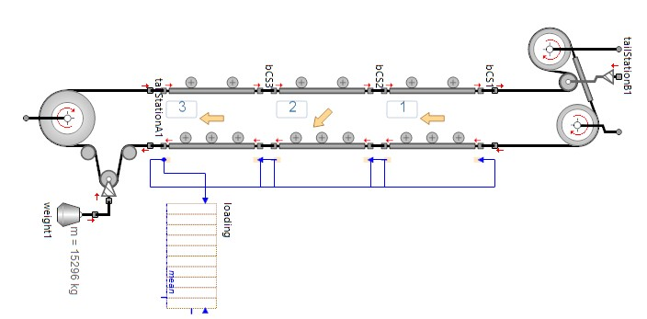
Figure 2: Three sequence belt conveyors (bc) with a series of loadings

To add more to its structural configuration, the belt conveyors is one of the lightest forms of conveying machine and comparatively less expensive and its supporting structures are used for many otherwise impossible structures such as crossing rivers and valleys. In this paper, we modeled belt Conveyors of a vehicle drive train with an idle speed controller for basic optimization of torque Pedals. The error rate for the test friction, the strand velocity, air gap and the speed controllers or torque pedals were computed. The method and materials used for estimated torque variation for pedal motion in machines with cycling capabilities is covered in the proceeding sections (Mehran, 2007).

The Belt Conveyor
To design belt conveyors, SimulationX was used, its automotive’ library contains basic controls for multiscale power engines, we first considered the length of the conveyor. The length of a conveyor from center to center of the end pulleys must have the same length inclination-level or inclined to the torque pedals. The degree of inclination or distance to the lifted or lowered pedals and also the average capacity per hour to the maximum capacity per hour of conveyors must also be considered. The materials to be conveyed in weight per cubic foot 6 or 7 and the average size of the materials are also areas that needs to be configured. Based on actual modeling, the simulated version might not closely represent the actual physical model but an estimated coefficient will help in understanding its basic parts and built when the designed model is tested.
One of the critical point to noted is the size of the largest pieces and percentage in feed, nature of the material or people, either dry or wet, such as their moisture content for abrasive or corrosive end. How the materials are to be conveyed or fed to the belt and particulars of feed point or points are also designated. Furthermore, how materials are to be discharge from the belt, that is, overhead pulley or by trippers and particularly if discharge points are for general indication of supporting structure.
And lastly power availability for driving, if the A.C. electric motor, state voltage, phase and frequency, would gauge the DC motor state voltage (Nasar, 1976; Lee & Chin, 1979). The average capacity per hour determines the suitability of belt conveyors, since inclination is a limiting factor. The size of the largest pieces and percentage in feed, determines the speed and width of the conveyor belt, the power needed for the drive, and the type of drive, also considering the number of belt plies, size of pulleys, the shaft and spacing of the idlers. The table below (Table 1), shows the maximum safe inclination for troughed belt conveyors’ handling, various materials for convenience correspond to the horizontal distances at different angle of inclination.

Table 1: Basic parameters for maximum safe inclination for troughed belt conveyors.
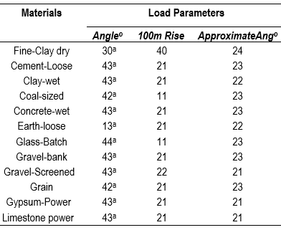
a is based on -10.

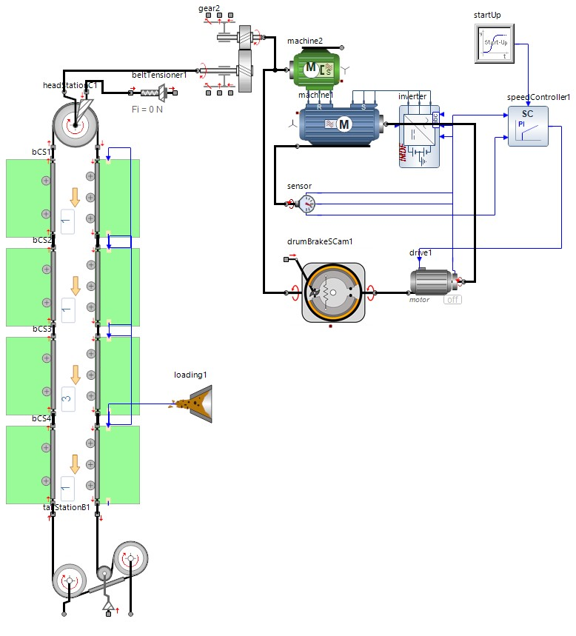
Figure 3: The model configuration of a vehicle drive train with four sequence belt conveyors and a loader

The Torque Variation
In most cycling machine, the pedaling technique is determined by variations in the torque applied to the pedals in a strand rotation situation. Quintana et al (2015) developed and also validated a method to compute the variations from the pedaling motion using an ergometer. The torque pedals is summed up to the torque needed to overcome all the resistance forces and the torque required for any changes of angular momentum of the ergometer flywheel. For validation of the method, they used direct pedal torque measurement and experiments shows pedal brake forces range between 100-250N. For most vehicle using cycling technique, the result is interaction between the operator of the vehicle and the environmental constraints as related to its concept. The proper selection of the variables involved in adjusting the vehicle position, seat height and strand length are necessary to prevent injuries during operation and to optimize the force distribution during the pedal stroke. Applying oriented forced to these pedals is a major component of skilled performance on the vehicle train.
The determination of the pedal force is one of the most fundamental part of an electric vehicle power train, from analyses of the cycling performance to biomechanical point of view. The sensors are implemented in the pedal pivot or at startup and could be validated in the literature for measuring force in one dimension up to three dimensions based on strain gauges or piezoelectric elements. The study of the pedal force in most vehicle motors is one of interest for several applications. Some related topics are limb co-ordination, pedaling biomechanics, human motion modeling and also detection and correction of asymmetry evaluation of body performance given a pedaling technique and workload effects of simple muscular efficiency. To calculate the angular acceleration from the pedaling motion, the angular position of the point representing the angular position of the strand is differentiated twice based on a single function. Dyck et al (2005) used SavitzkyGolay filter to obtain the filtered components required for the calculation of the second derivative of the angular position of the strand. The comparison of the results, which is a direct measurement of strand torque, provides the validation of their proposed methods. Following the methods by Dyck et al (2015), the Support Vector Machine is adopted for this paper, to obtain the filtered components of all parameters and controls used for modeling.

MATERIALS AND METHODS
The method used here involves the application of support vector machine algorithm created in SimulationX for the test runs and for most part. The paper focused on a typical speed controller of the vehicle train for the induction machine (vehicle drive train). The belt conveyors were utilized and the converter is modelled by a Frequency converter element, a couple of compound element from the library in simulationX, separate elements such as the Field Oriented Control (FOC) (Figure 4) to the torque pedals or speed controllers and the Support Vector Machine (SVM) (Algorithm 1) were not lumped to avoid constant bit error rate reduction. The model elements are complex and simple enough for efficient creation of the controller model structure. A 4 phase AC voltage of belt conveyors with a single loading was required, which is supplied by the power supply element that optimizes the torque pedals. Simulations were conducted and result shows a synchronized transmission patterns which is based on friction, the strand velocity and air gap of torque controls.
For proportionality of the torque pedals and speed controllers, we assume the angular position of the pivot point for stiff rotation of the pedal and the angular position θ, with respect to the center of the rotation, which have similar characteristics. So 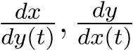 denote the coordinates of the point representing the angular position of the strand, with point of origin at the coordinate system placed at the center of the rotation. The angle is given by 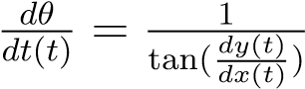

The end equation is given as:
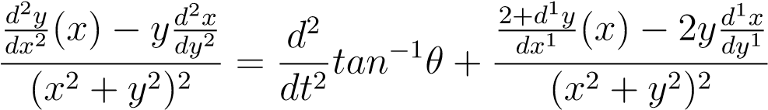 (1)
In the model parameters the FOC and SVM filter is applied separately to the coordinates in the x and y axis of the torque pedals in motion, in order to obtain a smooth curve and the third order differential function. The smooth resulted curve is shown in the result gragh discussed in the proceeding section below.
The Field Oriented Control (Figure 4) controls the magnetic synchronous motors or machine in a 4-phase BLDC or stepper motors with a rotor-estimator and speed-calculator, this is done by using the current control with a phase-voltage to control the torque pedals with high accuracy and bandwidth. This is implemented on the hardware and software of the model’s configuration with a DC bus control (DCBus). It is also one of the simple way of handling issues related to actual current and rotor position information. The field oriented control structure is based on the equation above. The actual phase currents is obtained by transforming the phase currents from stator-fixed to field synchronous coordinate systems. The resultant system coordinate is proportional to the motor’s torque which is a two dimension orthogonal components visualized as a single vector, hence its vector control.

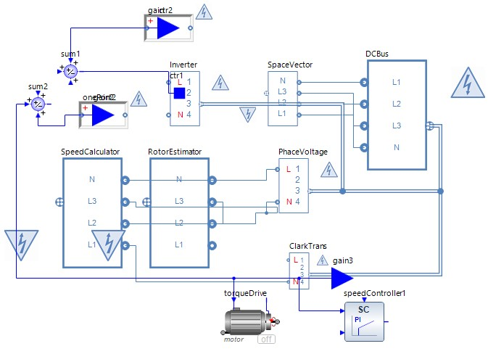
Figure 4: Field Oriented Control to the torque pedals or speed controllers.

Support Vector Machine
The support vector machine is the discriminative classifier algorithm formally designed and defines by a separating hyper plane or steps in this case. In order words, given the labeled parameters for the speed controllers and pedals, the algorithm serves as an output optional hyper plane that categorizes new exemplars. In the dimensional environment the hyper plane is the demarcation between the two pairs, where each class lay on both sides of the plane. The step by step algorithm (Algorithm1) illustrates a concise process to obtain the model parameters and a clear curve.
Result: Input: t := 0,n := m,n∗:= N
Result: Output: termination length n∗Initialization: t = 0,n = m,n∗= N ; while Repeat until a solution that satisfies equation above do
Choice the hypothesis to generate set
LOOP Process
t = l − 2 to 0 t := t + 1
end
IF 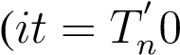) and (n < n∗) then n := n + 1 ;
while Semi random set M_{t} of size m do
If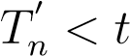, then the same contains value m − 1 points selected for size U_{n−1} at random and U_{n} else
Select m points from U_{n} at random times end ENDIF END ;
while Model parameter estimation do
Compute model parameters p_{t}from the sample M_{t}
Verify model
If consistent points (support) of the model with parameters p_{t}select termination length n∗
end else RETURN p

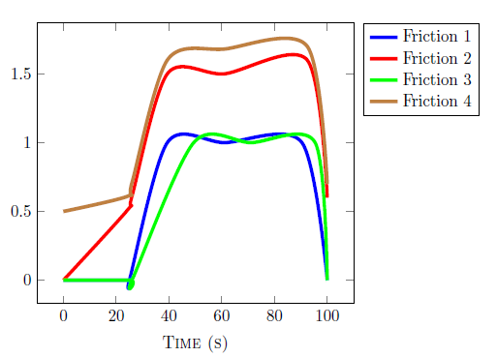
Figure 5: Test runs for torque pedals and belt conveyor on friction load
Figure 6: Test runs for torque pedals and belt conveyor on speed control load
Figure 7: Test runs for torque pedals and belt conveyor on air gap load

RESULTS
In the simulation environment, maximal isometric torque was recorded for the test runs, we recorded the friction, speed control, air gap torque and the strand velocity on pedaling motion using simultaneously four group runs and a motion capture app (Windows 3D visualization tool), which recorded videos with a sampling frequency between 0 − 15² . Our main aim is to determine at what extent is the net torques for pedals computed when the above mention Equation 1 and Algorithm 1 is utilized with P as friction on pedals. This is mostly based on the strand velocity as usually noted in most research (5). The Figure 9 shows the highest friction at the fourth simulation test run and the least friction at the third run, this would signify less grease in contact between pedals and wheels and also high contact in motion between two terminals based on our input parameters. Normally, a prototypical simulated model of the vehicle drive train is mostly closely related to the real life model or design. So, for this case and based on the assumption that the motion in torque pedals is directly proportional to the motion in control machine, the simulated results shows synchronous behaviour in measurement.
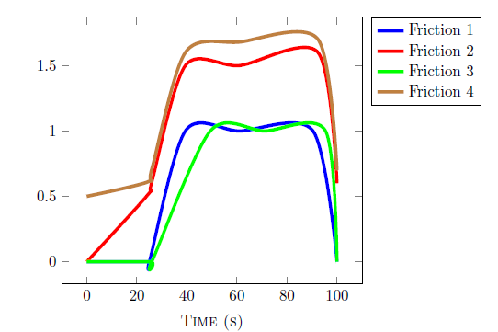
Figure 8: Test runs for torque pedals and belt conveyor on strand velocity load

For Figure 6, the main goal is to understand the proportionality between torque and speed control and this is computed using the above equation based on numerically approximate acceleration for pedal measurement, this is also close to the directly measured or simulated net torques. The 3D visualizer also recorded the designated parameters and simulated results. And all test runs show similar characteristics and simultaneous control in machine motion at a 1.5⁻³rpm per seconds. The highest and lowest value of peak torque was recorded during one of the simulated test between 1.5⁻³rpm and 5.5⁻²rpm. The lowest of the speed control was recorded in unloaded or less loaded conditions. All figures demonstrates the torque-velocity relationship and also power-velocity relationship. This is also true for air gap between pedals and wheels. Figure 9 demonstrates the axial air gap induction motors with rotors; this includes a typical two-dimensional current distribution in the machine or rotor. It considers circumferential and also a radial-angular dimensionality. The arrangements in the plot also indicates synchronous flow in logic or current for every simulated test.

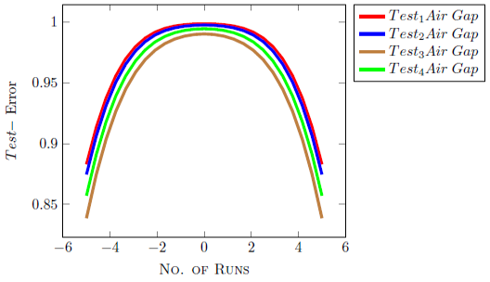

Figure 9: Error Test runs for torque pedals and belt conveyor on air gap
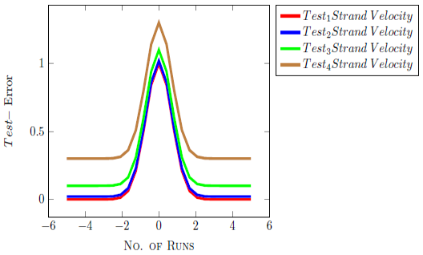
Figure10: Error Test runs for torque pedals and belt conveyor on strand velocity
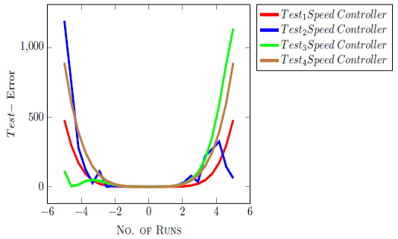
Figure 11: Error Test runs for torque pedals and belt conveyor on speed control.

Error in Torque Pedal Test Runs
To evaluate the error for test runs on torque motion of the analytical model, such as the axial air gap, friction, speed control, and strand velocity for the induction engine, the space harmonics is selected. The machine has six pole connectors (Figure 3) and two phase, other specifications are shown in the diagram. In order for the effects of the harmonics to be high, one of the minimal slot per pin hole is connected and rerun at least four times, taking note of the errors. It is observed that the results of the presented methods have higher accuracy in comparison to the simulated ones. The relationship between the error and accuracy during maximal drive is linear over functional rage of 60% , but methodological problems have never the less prevented measurements at low velocity of movement, thereby yielding high error in advance. Measurements recorded from the isometric model during two seconds interval and at maximum velocity has generated low error rate when compared to five seconds in between. Generally, this symbolizes a maximal peak power that occurred at strand velocity and demonstrates the importance of recording strand velocity in measurements of dynamic maximal power of the drive train.

Conclusion
This paper is based on optimization of torque pedals by modeling belt conveyors and speed controllers of a vehicle drive train, the test runs were based on the model equation and algorithms has been presented as a filter for the modified parameters. The simulated analytical method considers almost all parameters and dimensions of the model that are configured. The result predict points of accuracy and error plot of the methods corresponding to all parameters given. The proposed method for optimization of vehicle drive train engine has the ability to form accurate performance prediction though based on simulation process. For future considerations we will be comparing these simulated results to the physical configuration in order to help designers to compute and evaluate performance of air gap between petals, friction, velocity and speed controls.

REFERENCES
Anwer Abdeen, M., Elsayed Salem, A., and Zhang, G., (2021), Longitudinal Axial Flow Rice Thresher Performance Optimization Using the Taguchi Technique. Agriculture,11(2), 88.
Biecek, M., Pepelnjak, T., and Puˇsavec, F. (2019), Production aspect of direct drive in-wheel motors. Procedia CIRP, 2019, 81, 1278-1283.
Boldea I., and Nasar S. A. (1975). Finite width, finite thickness and saturation effects in solidrotor induction machines,” IEEE Trans. Power App, Syst., vol. 94, no. 5, pp. 1500–1507.
Carvalho, R., Nascimento, R., D’Angelo, T., Delabrida, S., GC Bianchi, A., Oliveira, R. A., and Uzeda Garcia, L. G. A, (2020), UAV-based framework for semi-automated thermographic inspection of belt conveyors in the mining industry. Sensors, 20(8), 2243.
Coyle, E. F., Costill D. L., and Lesmes G. R. (1979). Leg extension power and muscle fiber composition. Med. Sci. Sports, 11: 12-15.
Christensen, L., Johannsen, P., Sinkjær, T., Petersen, N., Pyndt, H. S., and Nielsen, J. B. (2000). Cerebral activation during bicycle movements in man. Experimental Brain Research, 135(1), 66–72.
Ciosk, K., Gierczak, E., and Mendrela, E. (1998). “Analysis of electromagnetic field in a disk induction motor with double-sided stator and twin rotors using a 3-D reluctance network method,” in ICEM. 98, Istanbul, Turkey, 1998, pp. 286–289.
Dahmen, T., and Saupe, D., Calibration of a Power-Speed-Model for Road Cycling Using Real Power and Height Data. International Journal of Computer Science in Sport, (2011), 10(2), 18–36.
Dern, R. J., Levene, J. M.,and Blair H. A. (1947). Forces exerted at different velocities in human arm movements. Am. J. Physiol, 151: 415437.
Dyck, D. N., Forghani, B., Brett, C. S., Webb, J. P., and Lowther, D. A. (2005). “A T-omega finite element method for arbitrary motion in 3D,” presented at the Compumag, Shenyang, China, 56-78.
Ettema, G., and Loraas, H. W. (2009). Efficiency in cycling: A review.European Journal of Applied Physiology, 106(1),1–14.
Faria, M., (2009). Recent advances in specific training for cycling. International Sport Medicine Journal, 10(1), 16–32.
Fenn, W. O., and Marsh. B. S. (1935). Muscular force at different speeds of shortening, J. Physiol. London, 85: 277-297.
Fugl-Meyer, A. R., Gustafsson, L., and Burstedt, Y. (1980). Isokinetic and static plantar flexion characteristics. Eur. J. Appl. Physiol. Occup. Physiol, 45: 221-234.
Gander, W., Golub, G. H., and Strebel, R.(1994). Least-squares fitting of circles and ellipses. BIT Numerical Mathematics, 34(4), 558–578.
Hochtl, F., Ohm, B.,and Senner, V. (2010). Prediction of energy efficient pedal forces in cycling¨ using musculoskeletal simulation models. Procedia Engineering, 2(2), 3211– 3215.
Ivy, J. L., Withers, R. T.,Brose, G., Maxwell, B. D.,andCostill D. L. (1981).Isokinetic contractile properties of the quadriceps with relation to fiber type. Eur. J. Appl. Physiol. Occup. Physiol, 47: 247-255l.
Komi, P. V. (1973). Measurement of the force-velocity relationship in human muscle under concentric and eccentric conditions. Med. Sport Basel, 8: 224-229.
Lee, C. H., and Chin, C. Y. (1979). “A theoretical analysis of linear induction motors,” IEEE Trans. Power App. Syst.,vol. 98, no. 2, pp. 679–688.
Maple ver. 7, Software User Guide. 2001, 34-56.
May, H. (1973). Analysis, performance and equivalent circuit of a disk-rotor induction machine, (in German) ETZ A, vol. 104, no. 10, pp. 574–577.
Mccartney, N., Heigenhauser, G. J. F.,andJones, N. L. (1983). Power output and fatigue of human muscle in maximal cycling exercise. J. Appl. Physiol, 55: 218224.
Mehran M., Mojtaba M. and Abdollahi, S. (2007). Analytical Modeling of Axial Air Gap Solid Rotor Induction Machines Using a Quasi-Three-Dimensional Method. in IEEE Transactions on Magnetics, 1-6
Mehran M., Mojtaba M. and S. Abdollahi., (2007), Analytical Modeling of Axial Air Gap Solid Rotor Induction Machines Using a Quasi-Three-Dimensional Method. in IEEE Transactions on Magnetics. 1-6.
Mendrela, E. (1996). Evaluation of magnetic field and forces in a single-phase induction disk motor with multi-layer rotor, Arch. Elect. Eng., vol. XLIV, no. 2, pp. 263–273.
Mu, Y., Yao, T., Jia, H., Yu, X., Zhao, B., Zhang, X., and Du, L. (2020), Optimal scheduling method for belt conveyor system in coal mine considering silo virtual energy storage.Applied Energy, 275, 115368.
Nasar, S. A., and Boldea, I. (1976). Linear Motion Electric Machines. New York: Wiley, 45-68.
Oberretl, K. (1977). Three-dimensional analysis of the linear motor, in Transport without wheels. London, U.K.: Elek Science, pp. 217–247.
Quintana-Duque, J.-C., Dahmen, T., Saupe, D. (2015). Estimation of Torque Variation from Pedal Motion in Cycling. International, Journal of Computer Science in Sport, vol. 14, 34-50.
Rossato, M., Faria, I. E., and BolliMota, C. (2007). Bilateral pedaling asymmetry during a simulated 40-km cycling time-trial. Journal of Sports Medicine and Physical Fitness, 47(1), 51–57.
Sjogaard, G. (1975). Force-velocity curve for bicycle work. Biomechanics VI-A, 93-99.
Thorstensson, A., Grimby, G., and Karlsson, J. (1976). Force-velocity relations and fiber composition in human knee extensor muscles, J. Appl. Physiol., 40: 12-16.
Tihanyi, J., Apor, P.and Fekete, G. (1982). Force-velocity-power characteristics and fiber composition in human knee extensor muscles. Eur. J. Appl. Physiol. Occup. Physiol, 48: 331-343.
Fleischer, J., Gerlitz, E., Rieb, S., Coutandin, S., and Hofmann, J., (2021), Concepts and Requirementsfor Flexible Disassembly Systems for Drive Train Components of Electric Vehicles. Procedia CIRP, 2021, 98, 577-582.
Yang, C., Bu, L., and Chen, B., (2019), Energy modeling and online parameter identification for permanent magnet synchronous motor driven belt conveyors. Measurement, 2021,178, 109342.

